FLOOD IN MAHANADI RIVER BASIN

**THE RIVER –**

The river Mahanadi originates in Bastar plateau in Madhya Pradesh. After a short run through Raipur and Bilaspur district it enters Orissa and then it takes a southernly turn upto Sonepur, where it meets with its largest tributary “Tel” Then turns East and flows up to the head of Delta at Naraj about 320 km down stream of Hirakud and there after splits into several branches. 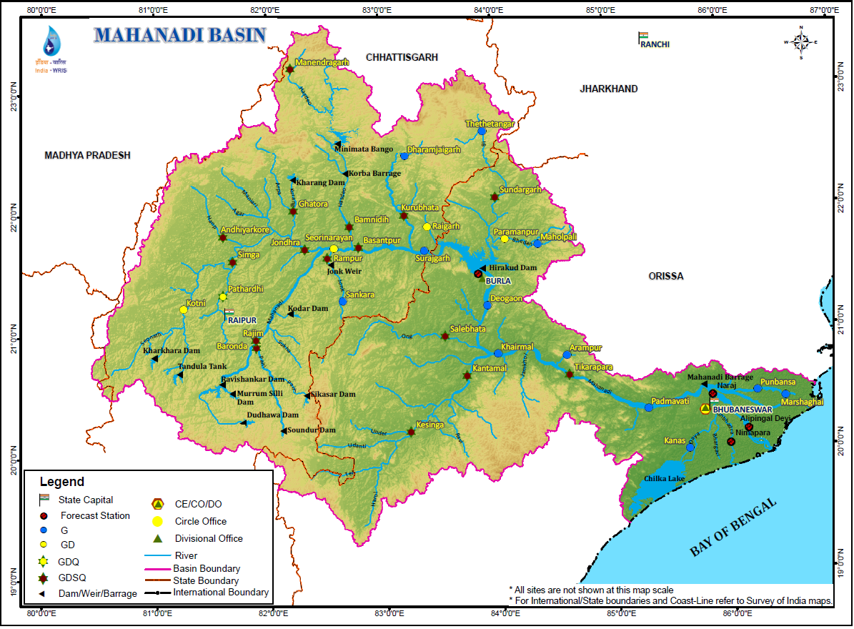The total length of the river from its source of origin up to the Bay of Bengal is about 860 km.

**Fig –2 .a**

The major tributaries up-stream of Hirakud dam are Seonath, Hasdeo, Mond, IB, Jonk etc. The main branches and sub-branches of Mahanadi are Kathjori, Birupa, Kuakhai, Kushabhadra, Bhargavi, Daya, Surua, Biluakhai, Devi, Chitrotpola, Luna, Karandia, Paika and Bada Genguti etc. Daya and Bhargavi fall into Chilika Lake while other branches including the river Mahanadi falls into Bay of Bengal.

In between the branches there are several drainage channels. To name a few important ones are Gobari, Alaka, Baghuni, Kula, Prachi, Dhanua and Nuna etc. All these drainage channels are prone to tidal effect near the Bay of Bengal. The catchment of Mahanadi is divided into three regions namely Region – I (drainage area between the source and Hirakud dam), Region –II (between Hirakud dam and head of delta) and Region – III (between head of delta and Bay of Bengal).



**REGION 1** –

The river Mahanadi originates in Bastar plateau in Madhya Pradesh. After a short run through Raipur and Bilaspur district it enters Orissa and then it takes a southernly turn upto Sonepur, where it meets with its largest tributary “Tel” Then turns East and flows up to the head of Delta at Naraj about 320 km down stream of Hirakud and there after splits into several branches. The total length of the river from its source of origin up to the Bay of Bengal is about 860 km. The major tributaries up-stream of Hirakud dam are Seonath, Hasdeo, Mond, Ib, Jonk etc. The main branches and sub-branches of Mahanadi are Kathjori, Birupa, Kuakhai, Kushabhadra, Bhargavi, Daya, Surua, Biluakhai, Devi, Chitrotpola, Luna, Karandia, Paika and Bada Genguti etc. Daya and Bhargavi fall into Chilika Lake while other branches including the river Mahanadi falls into Bay of Bengal. In between the branches there are several drainage channels. To name a few important ones are Gobari, Alaka, Baghuni, Kula, Prachi, Dhanua and Nuna etc. All these drainage channels are prone to tidal effect near the Bay of Bengal. The catchment of Mahanadi is divided into three regions namely Region – I (drainage area between the source and Hirakud dam), Region –II (between Hirakud dam and head of delta) and Region – III (between head of delta and Bay of Bengal).

**REGION 2** –

The area of this region is 50,745 km2. The Ong which drains Sartaipali, Padampur and Bijepur area joins Mahanadi further downstream. Tel, a very large tributary drains Deobhog, Bhawanipatna and Bolangir meets Mahanadi at Sonepur. Around 83 small and big channels carry flood water of this section to Mahanadi.

Further downstream Udayagiri and Phulbani areas of this region are drained by Salki which meets Mahanadi on the right bank upstream of Boudh. Daspalla, Nayagrah and Bolgarh area is drained by the tributaries Kuanria and Kusumi. Boudh, Barmul, Banki and Kaimundi area situated on the right bank of Mahanadi of this section and Baramba, Athgarh, Narsinghpur situated on the left bank.

**REGION 3 –**

Embankments in Kathjodi from Khannagr to Mattagajapur and the Mahanadi right embankment from Jobra to the downstream end of Cuttack need further strengthening.

The main river in this region divides into a number of branches. During the course of Delta formation, some islands have been formed between various channels and those islands are subjected to continual flooding during the monsoon due to spill of the channels. Birupa has bifurcated into Genguti and Birupa and these two branches flow into Kimiria and finally to Brahmani. This forms the Birupa–Genguti Island. Mahanadi divides into Chitrotpala, Nuna, Paika and Sukapaika and forms a number of islands.

All these Islands are flood prone. Similarly, the Kathjori branches into Kathjori, Sirua, Biluakahi, Devi, Kandal, Taunla and numerous other small channels which join toghether and flow down through the common mouth of thus creating the Kathjori, Surua, Devi-Biluakhai, Devi-Kandal, Devi-Taunla islands and other small islands which are flood prone. Kuakhai has bifurcated into Kushabhadra, Bhargabi and Daya. Kusabhadra has an independent mouth to the sea whereas Bharagabi and Daya reunite and discharge into Chilika Lake.

**DESCRIPTION OF DOABS**

Mahanadi-Delta command area has been divided into 8 doabs separated by wide and large rivers making the doabs independent. They are as follows:

Doab-I Mahanadi-Kathajori-Devi.

Doab-II Mahanadi/Chitrotpala-Luna-Birupa.

Doab-III Luna-Chitrotpala).

Doab-IV Area to east of HLC Range-I.

Doab-V Kathjori-Kushabhadra.

Doab-VI Kushabhadra-Bhargavi.

Doab-VII Daya-Bhargavi.

Doab VIII West of Daya.

**RAINFALL**

The catchment of Mahanadi receives rainfall from SW monsoon. During monsoon, there are some very intense rainfall spells which cause high runoff. It is now observed that the variability of daily rainfall is increasing which means that rainfall is not evenly distributed as it was earlier. Thus the floods are likely to be peakier. It is also observed that variability of monthly rainfalls is also increasing which means that rainfall is concentrated in a particular period. Volume of flood events are increasing, 2001 and 2003 floods are examples.

**Table 1: 1 and 2-day rainfall maxima as a function of area**

**Area (km2.) Rainfall Depths (mm)**

**1 – Day 2 – day**

1000 521 737

5000 434 653

10000 366 574

20000 292 465

50000 198 366

100000 142 279

(Period 1901-1950) *(Source: Hydrology Project Report)*

**FLOOD PROBLEM IN MAHANADI BASIN**

The catchment area of Mahanadi is divided into two distinct reaches -

(i) Upper Mahanadi (ii) Mahanadi Delta.

The upstream catchment of Mahanadi is mountainous and has a steep slope. The catchment lies directly on the south west monsoon track and as such receives heavy rainfall during monsoon. Besides, the catchment area close to the sea is prone to heavy rain brought about by the cyclones generated in the Bay in September – November. Thus the catchment has the potential of producing very high flood. The delta area is plain and has a flat slope. Due to flat topography of the delta area the excess flood water is not discharged to the sea quickly and as a consequence, Mahanadi Delta area gets flooded when peak flood discharge exceeds a certain limit. Upper Mahanadi area above Naraj does not have any significant flood problem due to topography excepting few places in IB ,Bheden and Tel.

**HISRORICAL FLOODS**-

Historical flood gauge are available at the following stations, at some places since 1855.

Naraj at Delta head (Danger Level - 26.52 m)

• Jobra Barrage on the Mahandi (Danger Level 26.52m)

• Birupa Barrage on Birupa (Danger Level 21.33 m)

• Bellevue near Cuttack on Kathjori (Danger Level 23.14 m)

• Naraj weir (Danger Level – 24.95/23.54 m)

From the history of flood events it is seen that in the pre- Hirakud period, out of a period of 79 years (1868 - 1946), there were 63 floods with peaks at the Delta head exceeding 10 lakh cusecs. The highest observed flood during that period was 15.71 lakhs cusecs in September 1834. In the post Hirakud period, 1958 to 2003, there were 16 high floods with peaks more than 10 lakh cusecs. The highest recorded flood was in August 1982 with a peak of 15.84 lakh cusecs. It has been estimated that had there been no Hirakud, the peak could have reached 17 lakh cusecs.

The worst flood of the 19th century in Orissa – The first on record, rolled down the Mahanadi system in Oct. 1834. Two-third of the houses of Cuttack district had been destroyed, loss of human life and cattle was also high. The discharge on Mahanadi during this flood was about 52,378 m3/s.

In 1866 water level at Naraj I.B. in Mahanadi and at Bellevue in Kathjuri rose upto 27.60m (90.52’) and 24.63m (80.80’) respectively. The flood discharge in Mahanadi at Naraj I.B. has been computed from Rhinds table to be 36,342 m3/s (1,283,600 cusecs).

Mahanadi was above danger level from 24th July to 7th August 1896 with a peak flood level of 28.07m (92.10’) at Naraj on 26th July. The flood discharge in Mahanadi at Naraj I.B. has been computed from Rhinds’ table as 42,529 m3/s (1,502,124 cusecs).

During this flood the water level at Jobra in Mahanadi and at Bellevue in Kathjuri rose upto 23.04m R.L. (75.60’) and 25.27m RL (82.87’) respectively.

During this flood, the water level at Naraj I.B. rose upto 28.00m with the peak flood discharge of 41,711 m3/s (1,473,233 cusecs) as computed from Rhinds table). The water level at Bellevue and Jobra rose upto 26.07m (82.25’) and 22.98m (75.40’) respectively.

***• Flood During 1933***:

During this flood, the water level in Mahanadi at Naraj I.B. rose upto 28.00m with a peak flood discharge of 41,711 m3/s (1,473,233 cusecs). The flood height at Bellevue and Jobra rose upto 25.07m (82.25’) 23.03m (75.55’) respectively.

***• Flood During 1937***:

During this flood the water level at Naraj I.B. rose upto 27.89m (91.48’) with the peak flood discharge of 40,189 m3/s (1,419,476 cusecs). The flood height at Bellevue and Jobra rose to a level of 25.04m (82.15’) and 22.97m (75.35’) respectively.

***• Flood During 1955***:

Another heavy flood swept the Cuttack district in July 1955. The flood discharge in Mahanadi during the flood was about 50,962 m3/s. There were about 1,360 breaches in the embankments. Cuttack was in a dangerous situation as the flood water over topped 900 years old stone revetment in many places at a velocity of about 7 M/ second.

The flood situation in Mahanadi and its branches worsened during the year 1955 because of the fact that there was wide spread rain through out the delta area simultaneously adding to the volume of water all along the course of the river in the lower reaches

The flood level at Naraj I.B. rose upto 27.18m (89.18’) with a peak flood discharge of 32,627 m3/s (1,152,386 cusecs). The water level at Jobra rose upto 23.22m (76.20’) on 6-9-1955 and this was the 2nd highest gauge reading recorded at Jobra so far in the history of Mahanadi flood in about a hundred years (1866 to 1955) against the highest recorded flood water level of 23.84m (78.20’) in the year 1896. The flood level at Bellevue in Kathjuri during the period rose upto level of 24.96m (81.90’) as against the earlier highest peak flood level of 25.39m (83.30’) during the year 1911.

***• Flood during the Year 1980:***

This year a very high unprecedented flood occurred during the 2nd half of September which created havoc at Lower part of Mahanadi system. The maximum flood height rose to a level of 27.80m on 22-9-80 at Naraj Railway Bridge against the danger level of 26.52m. The flood discharge at the site was measured to be 34,753 m3/s (1,227,476 cusecs). On actual observation it is found that the distribution of flood in Mahanadi and Kathjuri system has shown the tendency to change. The total volume of high flood in Mahanadi system decreased to 36% where as in Kathjuri system is increased to 64%. Therefore severe damages were caused due to breaches mainly in Devi river embankments.

***• Flood during the Year 1982***:

The flood was more serious in nature than any in recorded history. One very special feature of this flood is that the peak was entirely due to the rainfall over the un-controlled catchment below Hirakud. There was no release of water from Hirakud reservoir since the gates were kept closed from 16:00 hours on 29th August to about 11:00 hours on 31st Because of the heavy rainfall in the catchment D/s of Hirakud the river started rising rapidly on 28th August 1982. The peak at the head of the Mahanadi delta at Naraj Railway Bridge reached at 17:00 hours on the 31st August with a flood level of 28.53m against the D.L. of 26.52m and remained steady upto 20:00 hours of 31st August. The flood level at Naraj I.B. rose upto 27.62m R.L. (90.58’). At Jobra the peak level rose upto 23.54m (77.20’) on 31st August, surpassing the recorded level 23.23m (76.20’) in 1955. Similarly the peak level in Kathjori at Bellevue was 25.50m (83.65’) against the danger level 23.14m which exceeded the highest recorded level 25.39m during the year 1911.

The flood discharge at Naraj Railway Bridge was found to be 44,749 m3/s (1,580,535 cusecs). On actual observation it is found that the discharges in Mahanadi recorded to be 42% whereas the discharges in the Kathjuri system were recorded to be 58%. Therefore, severe damages were caused due to breaches mainly in Devi river embankments.

From the available information of flood level it is analysed that the flood level of 1982 was the highest in the second half of the 20th century. But the level at Naraj I.B. was higher than this at least on five occasions during 19th century floods (as per data available from 1855 to 1900) during the years 1872, 1879, 1892 and 1896. During 20th century the flood level of 1982 has been exceeded nine times during the year 1920, 1925, 1926, 1929, 1933, 1937, 1939, 1940 and 1944.

During this flood, Mahanadi remained above its danger level at Naraj Railway Bridge from 4:00 hrs on 30th August to 4:00 hours on 2nd September. Due to release at water from Hirakud it was again above the D.L. (26.52m) from 15:00 hours on 2nd September to 5:00 hours on 4th September.

• ***Flood in 1991***:

A heavy rainfall was experienced in both lower and upper Mahanadi basin due to low pressure during the 1st half of August. The rainfall in lower basin was unprecedent.

Out of the total d/s catchment of 48692 km2 the catchment below Khairmal contributed a peak discharge of 6.81 lakh cusecs due to above rainfall.

On 14th August 1991 at 12:00 hours flood peak of 35,985 m3/s was experienced at Munduli which raised Bellvue gauge at Kathjori to 25.40m. Discharge from Hirakud spill varied from 2123 m3/s to 2576 m3/s while flow to the reservoir increased from 4246 m3/s to 8493 m3/s.

***• Floods in 1992***:

Flood from 26th July to 3rd August

Consequent upon low pressure followed by depression a significant rain fall occurred both in lower and upper Mahanadi basin. The intense rainfall of 477.4 mm at Phulbani, 325.8 mm at Kharimal and 266.2 mm at Salebhata caused flood peak of 32106 m3/s at Mundali, without any contribution from Hirakud reservoir.

The u/s flood with peak 13,476 m3/s was accommodated in the reservoir and the level of Hirakud reservoir rose from 184.38 m to 188.109 m.

***• Flood of 2001***:

This flood event occurred during the period of 18/7/01 to 22/7/01. It had two peaks i.e. one with a peak of 13.92 lakh at 18 hrs of 17/7/01 and the other one with a peak of 14.00 lakh cusecs on 20/7/01. This event was caused by the contribution from both from u/s and d/s catchment. It is estimated that in the absence of Hiakud, the peak would have been very high.

***• Flood of 2003***:

This flood event has the unique feature of very high flood continuing for a long time. It occurred during the period 25/8/03 to 09/09/03. It had also two peaks. The first peak with a flow of 13.50 lakh cusecs was experienced at 3:00 hours on 30/8/03 and the second peak on 03/09/03 at 9:00 hours with a flow of about 10.50 lakh cusecs.

**FLOOD DAMAGE**

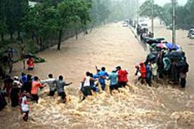 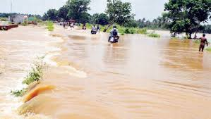

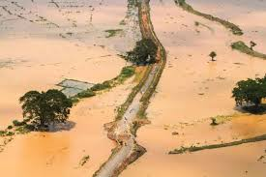 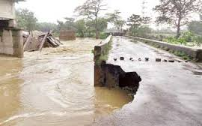

The highly populated area in the delta is protected by flood embankments. Flooding in this area is caused due to breaches in the embankments during high flood. In some areas there are number of escapes through which the flood water enters into the country side even during smaller floods and inundates the cultivated lands besides damaging the communication, irrigation system with occasional loss of human and animal lives.

At present about 1/3 rd of the Mahanadi Basin area suffers from persistent flooding and drainage congestion.

Due to poor drainage system of the area, the flood water stays on and damages the crops and canal system, public and private utilities and properties. When this flood water combines with local rain water, the problem becomes more severe and acute.

***• Flood Damage During 1866***:

As stated earlier as the flood discharge in Mahanadi at Naraj I.B. was computed to be 36,342 m3/s (1,283,600 cusecs). The peak was not so high but the flood was of very long duration. In Puri district, an area of about 777 km2 was submerged for about 5 to 45 days. The depth of inundation varied from 1 m to 3 m. Four lakhs of people were rendered homeless.

But in the district of Cuttack the area was inundated due to embankment breaches in 413 places. 1662 km2 of areas in the district were affected and submerged for a period varying from 3 days to 60 days. The depth of inundation has also been reported to vary from 1m to 5m About 7 lakhs of people are said to have been thrown out of their homes. All the crops of the submerged area were destroyed. A famine of most intense character known as “Na-Anka Durbhikshya” occurred, which was the greatest calamity in Orissa in the 19th century. The mortality was reported to be 10 lakhs out of 37 lakhs population of Orissa and 260,000 tons of Rice was lost due to occurrence of 478 numbers of breaches.

***• Flood Damage During 1896:***

As per the report of Mr. W.A. English, the then Superintending Engineer, Orissa Circle, there was a total devastation in the delta caused by flood and breaches of about 300 m length with 10 m depth of scour were noticed in the embankments. Besides damage to crops and several houses, communication was greatly affected and the irrigation system in Kendrapara and Pattamundai area was badly affected.

***• Flood Damage During 1933:***

It is remembered as one of the highest floods of Orissa on account of very severe breach on Sirua right bank at Khanditar and there were also other breaches. Total loss of human life was 8 and of livestock 162. All together 3919 houses were ruined and 7565 houses were damaged in Cuttack district. Crops on 39,172 ha were completely damaged while 6586 ha were partly damaged. On 6519 ha, no crops regenerated and 1104 ha of land were completely sand cast.

***• Flood Damage During 1937:***

There were in total 75 breaches due to the flood. Loss of life in Cuttack and Puri was reported to have been six. The number of cattle lost in Cuttack and Puri was 1,14,758. Crops in 80,531 ha were damaged in three districts of Cuttack, Puri and Sambalpur while a total of 2252 ha were sand casted. The number of houses damaged either partly or completely was 3378 in Cuttack and 2579 in Puri.

***• Flood Damage During 1955***:

A mighty flood of 50962 m3/s flowed over Cuttack district in July 1955. There were 1360 breaches in the embankments. The flood water was reported to have over topped 900 years old stone revetments surrounding the city.

Devastation caused by this flood is remembered due to the breach at Daleighai for a width of 610m (2000’). In the Sadar Sub-division of Cuttack a large, thickly populated, protected and irrigated region which is more or less granary of the Cuttack district, was inundated. Moreover on account of the suddenness of flood and the high velocity with which the floods descended in Mahanadi and its branches, caused a number of breaches in river embankments, wide spread inundation of the fertile and populated areas of Cuttack and Puri district. Extensive devastation was also caused in breaching of the roads and completely washing away of some villages and sand casting in large area of paddy lands in the districts of Cuttack and Puri. The whole area between Mahanadi and Chilika lake looked like almost one sheet of water. Villages were marooned for days together. Besides, causalities, involving loss of human life, there were disconnections in roads, railways and telegraphic services and communications by water. The breaches caused heavy damages to crops and houses. The extent of damage by the flood of this year would have been considerably greater, but for Hirakud, which though incomplete in those days could route and reduce 8500 m3/s (3 lakh cusecs) of water out of total inflow of 25,500 m3/s (9 lakh cusecs). According to the opinion of the Engineering experts, if all 9 lakhs cusecs of water had been allowed to pass from Hirakud the entire delta region of the district of Cuttack and Puri would have been a sheet of water including the city of Cuttack. In spite of some flood moderation by Hirakud the entire area to the north east and south east of Cuttack city was completely under water for about 10 days.

During the flood of 1955 there were altogether 263 breaches in river embankments of Delta Stage-I and Stage-II area. About 1086 nos. of villages and 116,900 ha of cultivated area were affected by the flood. In Cuttack district 1160 ha and in Puri district 567 ha of land were sand cast. 101 nos. of houses were swept away in the district of Cuttack and 425 nos. of houses collapsed in both the districts. A population of about 1,415,000 were affected due to this flood.

• ***Flood Damage During the Year 1980***:

This flood resulted in 92 breaches in the river embankments of Cuttack district. Amongst these, the worst breach occurred at Birabarpatna in the left bank of Biluakhai River. The length of the breach was 400 m. There were about 800 breaches in the canal banks of distribution system.

In Puri district 20 breaches occurred in the river embankments. The mouth of Gabakund cut got opened up. The worst breach occurred in right bank of Devi River at Jharpada for a length of 200m in the Govindpur P.S.

In Cuttack district 208 Grampanchayats and 1082 villages were affected, whereas in Puri district 168 Grampanchayats and 1136 villages were affected by the flood.

The Mahanadi delta command area has sustained high loss both in life and properties due to this flood. 54 blocks and 3140 villages were affected. Eighty-one breaches occurred in river embankments. The distribution system had breached at 787 and 1049 places respectively. About 2.39 lakh ha of cropped area were affected due to this flood in entire Mahanadi delta command area. Human life lost during this flood was reported to be five. The nos. of houses swept away, collapsed, partly damaged have been totalled and reported as 135,726. The total population affected by the flood is 20.56 lakhs in Cuttack and Puri districts.

• ***Flood During the Year 1982***:

The devastation extended over an area of 90,000 km2. 114 blocks, 7 Municipalities and 16 N.A.C A population of more than five million people were severely affected. Human casualities were reported to be 175. Embankments for Mahanadi and its branches have breached at several places and about 12 lakh ha of cultivated land was innundated. The road net work was cut to ribbons. Bhubaneswar, Cuttack, Boudh, Manmunda, Sambalpur, Puri, Paradeep, Jagatsinghpur, Kendrapara, Nimapara, Pipili, Gop, Kakatpur and other important towns were cut off due to major road breaches. National highway No. 5 linking Calcutta to Madras breached badly and traffic was dislocated for more than a month. The canal distribution system in Cuttack, Puri and Sambalpur districts were damaged. The most serious breach occurred in Daleighai, Kantapada and Birabar Patna in left bank of river Debi in 3 places varying from 400 to 500m in length. Breaches caused due to the flood at Daleighai resulted in large devastation – causing wide spread damage and destruction to nearly a million families in the so called rice bowl of Orissa. Extensive areas of Puri and Cuttack district continued to remain submerged under water for a period of about 30 days.

Emergency relief had to be brought to the marooned people in the affected areas through air dropping, the rescue operations continued by the army personnel for days together. The fate of Cuttack city hung in a balance for 3 days as a result of water seeping through vulnerable points and over topping of embankments at some places thereby inundating the low lying areas of the city.

The flood was so severe that three historic rivers such as Prachi (silted up about 100 years back) and Alaka (silted about 200 years back) have opened up during this flood.

**Table2. Few major floods of Odisha basins**

**Sl.No. Year River Month of occurrence Area affected in Lakh hectare**

1. **1980** Mahanadi, Brahmani, Baitarani & September **3.19** Vamsadhara

2. **1982** Mahanadi, Rushikulya August- September **12.00**

3. **2001** Mahanadi, Brahmani,Baitarani, Subarnarekha, July –August **7.99**

Burhabalang, Vamsadhara, Rushikulya &

Indravati

4. **2003** Mahanadi, Brahmani, Baitarani Subarnarekha, July- October **5.03**

Burhabalang, Vamsadhara, Rushikulya &

Indravati

5. **2006** Baitarani, Mahanadi, Rushikulya, Vamsadhara, July – August **3.04**

Burhabalang & Indravati

6. **2008** Mahanadi, Brahmani, Baitarani September

7. **2011** Mahanadi September

***Source: Flood Management Manual (2008) DOWR up to Sl. No. 5***

The devastation of flood in the district of Cuttack and Puri was more serious than in any other districts in the upper reaches of Mahanadi.

In both the districts 57 nos. of Blocks and 1712 nos. of Grampanchayats were affected due to this flood. The no. of villages affected in the district of Cuttack is 4478 and in the district of Puri is 2126. A population of 33.78 lakhs in the district of Cuttack and 11.78 lakhs in the district of Puri are said to have been affected during the flood of 1982. As per white paper published by Government the total no. of houses swept away, collapsed and or partly damaged in the district of Cuttack and Puri is 421,511. 17063 nos. of live stock are lost during the flood in the district of Cuttack and Puri. The total no. of breaches in the river embankments of Cuttack and Puri district in Stage-I and Stage-ii area is 420. Cropped area affected is 4.671 lakh ha Due to the breaches 75000ha of land in Cuttack and Puri district got sand cast.

***Flood in 1991***: A peak flood of 32,106 m3/s struck at Naraj river embankments of Mahanadi, Kathjori, Devi, Kandal, Birupa, Luna, Chitrotpala, Paika, Hansua in undivided Cuttack district and Kuakhai, Kushabhadra, Daya, Bhargavi, Kuanria and Burtanga embankments in Puri district breached affecting cropped area of 6.77 lakh ha. There were wide spread damages to irrigation distribution system, road network, private land, school building and public institution etc.

**Table 3.ECONOMICAL DAMAGE BY FLOOD**

**Year Crop House Public utility Total in 1988 base Average annual**

**Damage damage damage lakh Rs @10%per flood damage**

1977 76.99 1.21 72.72 150.92 430.6

1978 133.68 11.22 320.50 465.35 1206.99

1979 N. A N. A N. A N. A N. A

1980 802.87 78.67 146.46 1026.99 2201.44

1981 N. A N. A N. A N. A N. A **13316.53/7=**

1982 1237.48 304.48 507.44 2049.40 3630.63 **19.03 core**

1983 N. A N. A N. A N. A N. A

1984 869.91 35.15 1472.34 1877.40 2748.70

1985 935.79 218.77 713.34 1867.90 2486.175

1986 368.10 12.86 125.23 506.19 612.5

